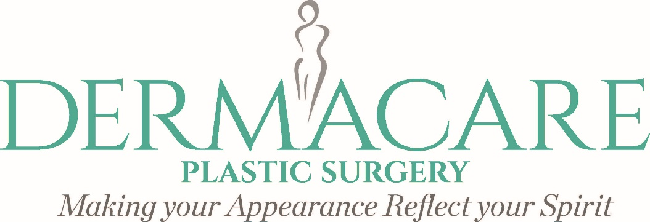
BOTOX INFORMED CONSENT
Prior to receiving treatment, I have been candid in revealing any condition that may have an effect on this procedure. Prior to receiving additional treatments, I will also inform Dermacare of any changes, if relevant, that may have an effect on this procedure.
INJECTION OF BOTULINUM A TOXIN (BOTOX™)
The following points have been discussed with me:
1. The mode of action of the treatment. Botox™ injection is used in the cosmetic treatment for glabella frown lines (between the eyebrows), forehead lines, neck lines, crow’s feet (around lower eyes) and significantly decrease sweating.
2. The proposed benefits of treatment. Injection of this material into the small muscles will cause them to temporarily halt their function, thereby improving the appearance of the wrinkles. This response is temporary, and re-injection is necessary within three to six months to obtain the desired result. There is a charge for areas that may require a touch-up treatment.
3. Risks. Risks include, but are not limited to, temporary paralysis of other nearby muscles, headache, local numbness, rash and bruising, and failure to respond.
ACKNOWLEDGMENT
I understand that Botox™ injections are not an exact science and that no guarantee or assurances can be given to me concerning the results of this procedure. Alternative means of treatment have been explained to me and I understand that I have the right to refuse the treatment.
I understand the FDA has approved Botulinum A Toxin (Botox) for cosmetic wrinkle reduction.
PHOTOGRAPHS: I give permission for photographs to be used by the DERMACARE staff for education plus promotional purposes. Complete patient confidentiality will be maintained at all times. ________ (please initial).
I consent to allow the medical personnel at Dermacare Plastic Surgery under the supervision and controls of R.N. to proceed with Botox injections. I understand that the medical personnel and other assistants will rely on statements made by me to determine that the procedure is safe and effective.
I HAVE READ AND FULLY UNDERSTAND THE TERMS WITHIN THE ABOVE CONSENT. ALL MY QUESTIONS HAVE BEEN ADDRESSED TO MY SATISFACTION. IN THE EVENT A DISPUTE ARISES OVER THE OUTCOME OF MY PROCEDURE, I CONSENT SOLELY TO ARBITRATION AS A LEGAL MEANS OF SETTLEMENT. I UNDERSTAND ENGLISH, OR IF I DO NOT, I HAVE APPOINTED SOMEONE TO TRANSLATE THIS CONSENT FORM IN ITS ENTIRETY. _____________________________________________________________________________________Patient’s Name (PRINTED) Translator Name (PRINTED -if applicable) Date _____________________________________________________________________________________Patient’s Signature Translator Signature (if applicable) Date _______________________________________________________________________________ Provider’s Name (PRINTED) Provider’s Signature Date

